1. **Operator Arithmatika**
2. BuatProjectbaru,berinamaproject,danpilihemptyactivity
3. Bukafileactivity_main.xml,laludesainwidgetmenggunakanlayout inear dan relative seperti berikut ini.

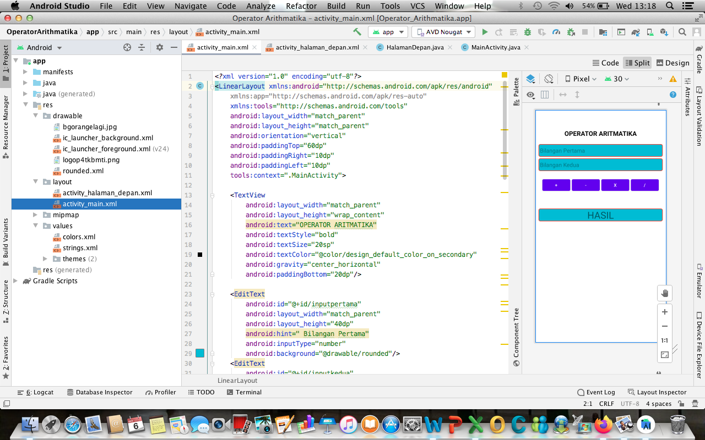

1. Atau bias dari tab code membuat coding seperti berikut ini.

<?xml version="1.0" encoding="utf-8"?>

<LinearLayout xmlns:android="http://schemas.android.com/apk/res/android"

xmlns:app="http://schemas.android.com/apk/res-auto"

xmlns:tools="http://schemas.android.com/tools"

android:layout_width="match_parent"

android:layout_height="match_parent"

android:orientation="vertical"

android:paddingTop="60dp"

android:paddingRight="10dp"

android:paddingLeft="10dp"

tools:context=".MainActivity">

<TextView

android:layout_width="match_parent"

android:layout_height="wrap_content"

android:text="OPERATOR ARITMATIKA"

android:textStyle="bold"

android:textSize="20sp"

android:textColor="@color/design_default_color_on_secondary"

android:gravity="center_horizontal"

android:paddingBottom="20dp"/>

<EditText

android:id="@+id/inputpertama"

android:layout_width="match_parent"

android:layout_height="40dp"

android:hint=" Bilangan Pertama"

android:inputType="number"

android:background="@drawable/rounded"/>

<EditText

android:id="@+id/inputkedua"

android:layout_width="match_parent"

android:layout_height="40dp"

android:layout_marginTop="5dp"

android:hint=" Bilangan Kedua"

android:inputType="number"

android:background="@drawable/rounded"/>

<RelativeLayout

android:layout_width="match_parent"

android:layout_height="wrap_content"

android:paddingTop="20dp"

android:gravity="center">

<Button

android:layout_width="wrap_content"

android:layout_height="wrap_content"

android:text="+"

android:onClick="prosestambah"

android:id="@+id/tambah"/>

<Button

android:layout_width="wrap_content"

android:layout_height="wrap_content"

android:layout_toRightOf="@id/tambah"

android:text="-"

android:onClick="proseskurang"

android:layout_marginLeft="5dp"

android:id="@+id/kurang"/>

<Button

android:layout_width="wrap_content"

android:layout_height="wrap_content"

android:layout_toRightOf="@id/kurang"

android:text="x"

android:onClick="proseskali"

android:layout_marginLeft="5dp"

android:id="@+id/kali"/>

<Button

android:layout_width="wrap_content"

android:layout_height="wrap_content"

android:layout_toRightOf="@id/kali"

android:text="/"

android:onClick="prosesbagi"

android:layout_marginLeft="5dp"

android:id="@+id/bagi"/>

</RelativeLayout>

<TextView

android:id="@+id/hasil"

android:layout_width="match_parent"

android:layout_height="wrap_content"

android:gravity="center_horizontal"

android:layout_marginTop="50dp"

android:background="@drawable/rounded"

android:text="HASIL"

android:textAlignment="center"

android:textSize="30sp"/>

</LinearLayout>

1. Buka file MainActivity.java, lalu buatlah coding berikut ini.

package com.odading.operatorarithmatika;

import androidx.appcompat.app.AppCompatActivity;

import android.os.Bundle;

import android.view.View;

import android.widget.Button;

import android.widget.EditText;

import android.widget.TextView;

public class MainActivity extends AppCompatActivity {

// Deklarasi Variable

EditText input1,input2;

TextView output;

Double v1,v2,hasil;

@Override

protected void onCreate(Bundle savedInstanceState) {

super.onCreate(savedInstanceState);

setContentView(R.layout.activity_main);

input1 = (EditText) findViewById(R.id.inputpertama);

input2 = (EditText) findViewById(R.id.inputkedua);

output = (TextView) findViewById(R.id.hasil);

}

public void konver(){

// Konversi tipe data ke double

v1 = Double.parseDouble(input1.getText().toString());

v2 = Double.parseDouble(input2.getText().toString());

}

public void prosestambah(View view){

konver();

hasil = v1+v2; // Penjumlahan

output.setText(Double.toString(hasil)); // Output

}

public void proseskurang(View view){

konver();

hasil = v1-v2; // Pengurangan

output.setText(Double.toString(hasil)); // Output

}

public void proseskali(View view){

konver();

hasil = v1*v2; // Perkalian

output.setText(Double.toString(hasil));

}

public void prosesbagi(View view){

konver();

hasil = v1/v2; // Pembagian

output.setText((Double.toString(hasil)));

}

}

1. Jalankan Program, inputkan bilangan pertama dan bilangan kedua, lalu klik salah satu operator misalnya tambah atau kali, maka akan terlihat output seperti berikut ini.
2. **Operator Logika**
3. Buat project baru, pilih empty activity, beri nama project sesuai keinginan
4. Buka file activity_main.xml, desain activity tambahkan edittext, button dan textview, seperti berikut ini.

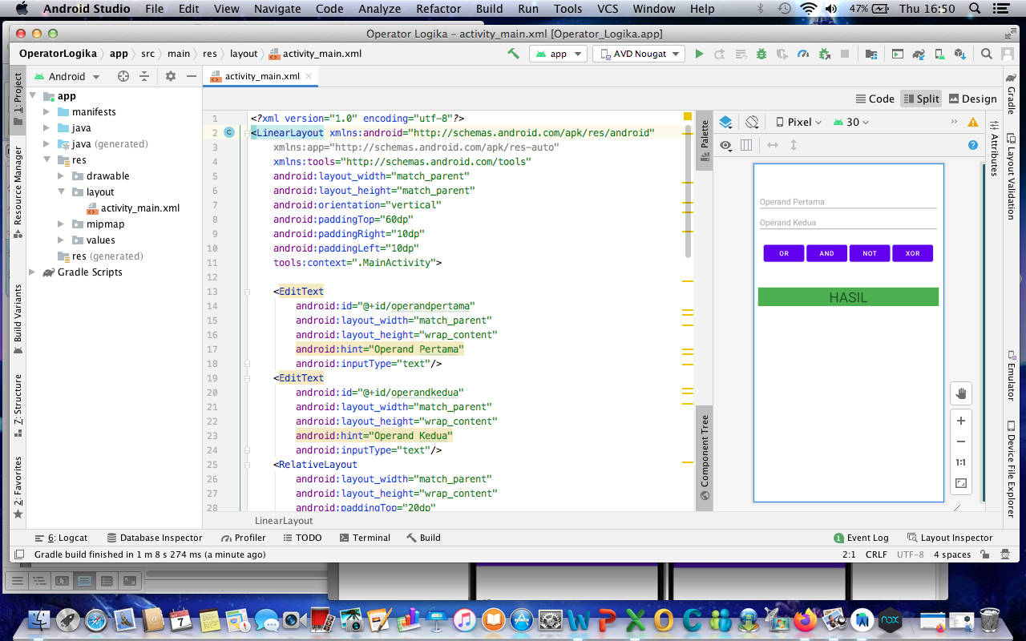

1. Atau bias dari tab code dan buat coding berikut ini.

<?xml version="1.0" encoding="utf-8"?>

<LinearLayout xmlns:android="http://schemas.android.com/apk/res/android"

xmlns:app="http://schemas.android.com/apk/res-auto"

xmlns:tools="http://schemas.android.com/tools"

android:layout_width="match_parent"

android:layout_height="match_parent"

android:orientation="vertical"

android:paddingTop="60dp"

android:paddingRight="10dp"

android:paddingLeft="10dp"

tools:context=".MainActivity">

<EditText

android:id="@+id/operandpertama"

android:layout_width="match_parent"

android:layout_height="wrap_content"

android:hint="Operand Pertama"

android:inputType="text"/>

<EditText

android:id="@+id/operandkedua"

android:layout_width="match_parent"

android:layout_height="wrap_content"

android:hint="Operand Kedua"

android:inputType="text"/>

<RelativeLayout

android:layout_width="match_parent"

android:layout_height="wrap_content"

android:paddingTop="20dp"

android:gravity="center">

<Button

android:layout_width="wrap_content"

android:layout_height="wrap_content"

android:text="OR"

android:onClick="logikaor"

android:id="@+id/button_or"/>

<Button

android:layout_width="wrap_content"

android:layout_height="wrap_content"

android:layout_toRightOf="@id/button_or"

android:text="AND"

android:onClick="logikaand"

android:layout_marginLeft="5dp"

android:id="@+id/button_and"/>

<Button

android:layout_width="wrap_content"

android:layout_height="wrap_content"

android:layout_toRightOf="@id/button_and"

android:text="NOT"

android:onClick="logikanot"

android:layout_marginLeft="5dp"

android:id="@+id/Button_not"/>

<Button

android:layout_width="wrap_content"

android:layout_height="wrap_content"

android:layout_toRightOf="@id/Button_not"

android:text="XOR"

android:onClick="logikaxor"

android:layout_marginLeft="5dp"

android:id="@+id/button_xor"/>

</RelativeLayout>

<TextView

android:id="@+id/hasil"

android:layout_width="match_parent"

android:layout_height="wrap_content"

android:gravity="center_horizontal"

android:layout_marginTop="50dp"

android:background="#4CAF50"

android:text="HASIL"

android:textAlignment="center"

android:textSize="30sp"/>

</LinearLayout>

1. Buka file MainActivity.java, lalu buat coding berikut ini.

package com.odading.operatorlogika;

import androidx.appcompat.app.AppCompatActivity;

import android.os.Bundle;

import android.view.View;

import android.widget.Button;

import android.widget.EditText;

import android.widget.TextView;

public class MainActivity extends AppCompatActivity {

// Deklarasi Variable

EditText input1, input2;

TextView output;

Boolean v1, v2, hasil;

@Override

protected void onCreate(Bundle savedInstanceState) {

super.onCreate(savedInstanceState);

setContentView(R.layout.activity_main);

input1 = (EditText) findViewById(R.id.operandpertama);

input2 = (EditText) findViewById(R.id.operandkedua);

output = (TextView) findViewById(R.id.hasil);

}

public void konver() {

// Konversi tipe data ke Boolean

v1 = Boolean.parseBoolean(input1.getText().toString());

v2 = Boolean.parseBoolean(input2.getText().toString());

}

public void logikaor(View view) {

konver();

hasil = v1 || v2; // OR

output.setText(Boolean.toString(hasil)); // Output

}

public void logikaand(View view) {

konver();

hasil = v1 && v2; // AND

output.setText(Boolean.toString(hasil)); // Output

}

public void logikanot(View view) {

konver();

hasil = !v1 ; // NOT

output.setText(Boolean.toString(hasil));

}

public void logikaxor(View view) {

konver();

hasil = v1 ^ v2; // XOR

output.setText((Boolean.toString(hasil)));

}

}

1. Jalankan program pada AVD, terlihat output seperti berikut ini.